Corporate Catering Guide Evening

About Us
Established in 2001, Big Bite Catering is a multi-award winning catering and Patisserie Company based in Airdrie.
We supply elite hotels, world renowned universities, leading corporate businesses and premier sports clubs throughout Scotland.
We pride ourselves on only using the freshest seasonal ingredients and sustainable products available. These products, along with the balance of experience, flair and imagination within our team allows us to create individual packages to compliment the style, location and occasion for each event.
Special dietary requirements pose no problem to our team of visionary chefs. Our aim is to exceed your expectations.

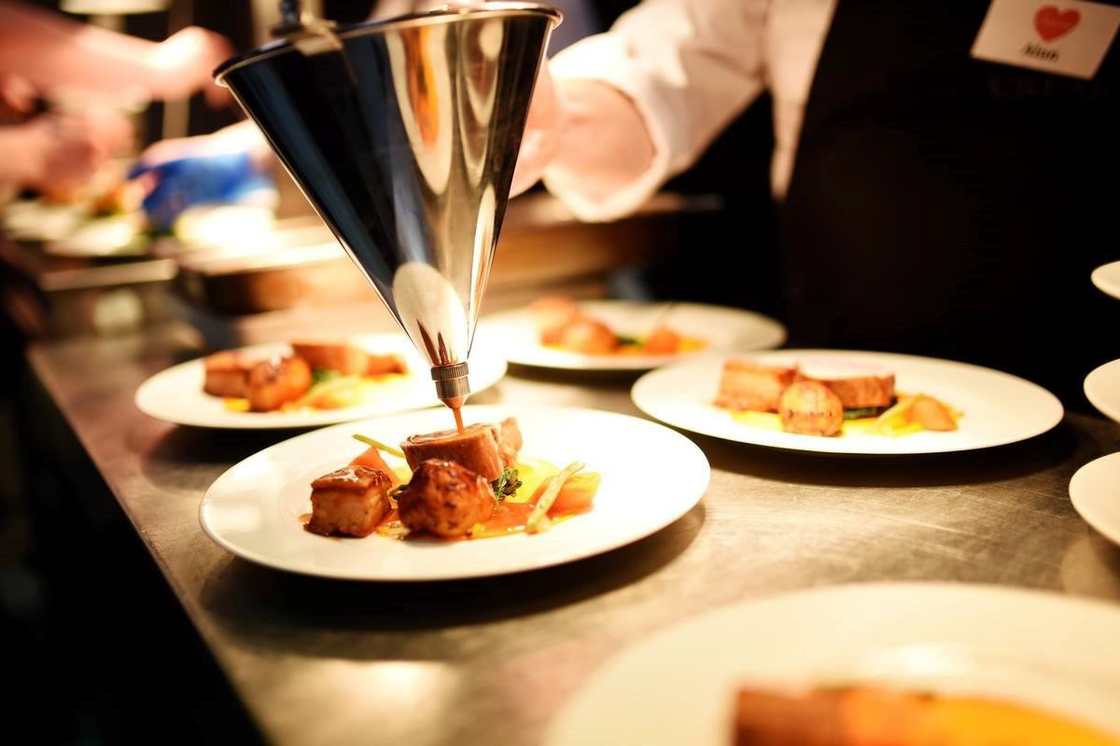

Canapé Selection
Vegetarian

Roasted cherry tomato on a parmesan shortbread with whipped cream cheese & chives
Tomato Arancini, Balsamic Jelly and Pine nut
Squash Cracker, Squash Puree, Pickled Beetroot, Pumpkin Seeds Whipped goats cheese on oat biscuit with baked fig and heather honey
Confit Potato, Truffle Mash, Parmesan Gratin Gougere, Cheese Fondue
Compressed Watermelon with Gin and Mint Gel Chick pea wafer, goat’s cheese curd & micro cress

Fish
Isle of Mull cheddar & smoked haddock fritter with cullen skink shot Crispy langoustine croquette with shellfish essence
Smoked salmon & dill mousse with creamed horseradish Tartlet of west coast crab with spiced mango
Confit baby potatoes with hot smoked salmon

Meat & Poultry
Crispy haggis balls with Arran mustard mayo Black Pudding with Homemade Brown Sauce
Carpaccio of Scottish beef on crisp parmesan shortbread Chicken liver parfait, Cherry and Brioche Toast
Beef Tartar, Pecan Tullie, Pickled Beetroot
Confit Ham Hough Croquette with Apple and Thyme Gel Mini venison & haggis sausage rolls

A selection of 4 canapés £8.00
A selection of 6 canapés £11.00, £1.50 per additional canapé All prices exclude VAT

Cold Evening Fork Buffet
Goat’s cheese curd with honey dressed figs on an oatie crunch biscuit
A selection of our home cured and smoked Scottish salmon with caper berry salad and creamed horseradish
Roast free-range chicken served carved with watercress salad, crème fraiche & horse radish dressing
Honey glazed Ayrshire ham with piccalilli Broccoli & mascarpone quiche
3 tomato & mozzarella salad with our own pesto dressing Traditional Caesar salad with garlic crostini
Chermoula style carrot salad
Summer salad with garden peas, asparagus and artichokes Spiced roast beetroot salad
Sour dough bread rolls Glazed lemon tart
A selection of Scottish cheese & biscuits with a selection of fresh fruit, nuts & crackers

£25.00 per person.
All prices exclude VAT

Hot Evening Fork Buffet
Main dishes
Beef chilli with braised rice and cheesy nachos
Indian chicken curry with basmati rice and homemade Naan bread Spinach & coconut dahl with flat breads & spiced rice
Tiger prawn curry with steamed rice & seasonal greens Lasagne and garlic ciabatta
Chinese chicken curry served with rice and crackers
Sauté chicken chasseur with baby potato and buttered vegetables Chicken and chorizo wraps
Chicken gumbo with rice pilaff
Chestnut mushroom stroganoff with braised rice Butternut squash and cranberry tagine

Salad selection
Traditional Caesar salad Peppered coleslaw
Spiced artichoke, asparagus & pea salad Chermoula carrots
Red cabbage, Wensleydale and apple salad Heritage tomato and mozzarella salad Potato salad
Moroccan spiced beetroot

Finger foods
Homemade sausage rolls, with or without braised onions Fresh vegetable sushi with vegan wasabi mayo
Whipped goats cheese curd with fig & truffle honey on an oat biscuit Spiced mango & strawberry skewers
Crispy haggis with Arran mustard mayo
Broccoli & mascarpone quiche or any quiche fillings Chicken wings with coconut cream
A selection of traditional pasties
Slow cooked pork ribs with sticky BBQ glaze

Desserts
Pear and almond tart served with crème fraiche Seasonal flavoured cheesecake
Seasonal fruit Pavlova
Lemon posset with shortbread fingers Rich chocolate torte
Glazed lemon tart Pecan pie

Choose 2 main course, 2 salads, 2 finger foods and 2 desserts
£19.50 per person

Choose 3 main course, 3 salads, 3 finger foods and 3 desserts
£ 22.50 per person

Choose 4 main courses, 4 salads, 4 finger foods and 4 desserts
£25.00 per person (only suitable for functions of 70 and above) All prices are excluding VAT

Tapas / Bowl Food Menu
A selection of sour dough breads & crostini with dips - which may include
- guacamole, bahbah ganoush or beetroot humus will be served with all menu choices

Nibbles
A selection of freshly prepared sushi with wasabi & pickled ginger Sweet & spicy chicken fillets with toasted cashew nuts
Ripe galia melon with black forest ham Slow cooked pork ribs in a sticky BBQ glaze
Mini sweet Caesar salads with garlic croutons Potatas bravas
Seasonal salad leaves with pickled beetroot, pear & goats cheese topped with spiced walnuts & raspberry dressing

Hot Dishes
Pasta shells in a rich tomato sauce with slow braised beef
Sauté chicken with chasseur sauce, crisp parmentier potatoes & wilted greens
Coconut, spinach & potato dahl with basmati rice, popadoms Tiger prawn curry with steamed basmati rice & seasonal greens Pork meatballs in loch Fyne ale gravy with minted peas & roasted mushrooms

Mini Sweet Treats
Passion fruit jelly with lemon cream & glazed lychee
Poached pear with burnt honey mascarpone mousse & oat crumble Cherry Bakewell slice
Dark chocolate & orange pots with shortbread fingers Crack pie – a moreish chewy corn custard… its addictive!

All options include a selection of dips and breads
Choose 2 nibbles, 2 hot dishes & 2 sweets £17.50 per person Choose 3 nibbles, 3 hot dishes & 3 sweets £21.50 per person choose 4 nibbles, 4 hot dishes & 4 sweets £27.50 per person (option 3 only suitable for 50 & above)
All prices exclude VAT

Executive Finger Food
Lemon & Garlic Poached Chicken with Ras Al Hanout and Honey Yogurt Dressing

Hot Smoked Scottish Salmon with our home cold smoked salmon mousse served on a crisp sourdough base
Braised Feather blade wellingtons with Homemade Brown Sauce Selection of Sushi with Pickled Ginger and Creamed Wasabi Roast Beetroot, Butternut Squash and Puy Lentil Pastry
Slow cooked pork belly with sticky glaze & Asian slaw

Whipped Goats Cheese Curd with Fig, Truffle Honey and Oat Crunch
Dark chocolate & orange pots with shortbread fingers

£20.00 per person. Includes a selection of all items on the menu All prices exclude VAT

Additional Services

Champagne, prosecco, wine & beer – Prices available on enquiry Soft drinks – Cans £1.75 each, Fruit juice £2.95 per litre, Water £2.95 per litre
Tea & Coffee - £3.25 per person Staff - £25 per hour
Crockery, cutlery, glassware – Price on enquiry
We can supply biodegradable disposable plates, cutlery & napkins –
Price on enquiry

For any orders under £100.00, a delivery charge will be added to the final invoice. Minimum delivery charge is £15 for local drops further away destinations would be charged accordingly.

All dietary requirements can be catered for on request.

